Ohio Teacher Evaluation System


Model
2012



Ohio Teacher Evaluation System | Preface

TABLE OF CONTENTS

Preface…………………………………………………………………………………………………………………………………... | 2
Definition of Teacher Effectiveness………………………………………………………………….…………. | 3
Teacher Performance ……………………………………………………………………………………………………………. | 4
Student Growth Measures……………………………………………………………………………………………………… | 5
Combining Teacher Performance and Student Growth Measures……………………………… | 8
Implementing the OTES Model
Professional Growth Plan and Performance on the Standards……………………………………. | 10
Improvement Plan and Performance on the Standards……………………………………………… | 11
Observation Process and Performance on the Standards……………………………………………. | 12
Student Growth Measures…………………………………………………………………………………………. | 14
Appendix A: Teacher Performance Rubric……………………………………………………………………………… | 15
Appendix B: Guidance on Using Evidence to Inform Holistic Performance Ratings………………... | 21

Ohio Teacher Evaluation System | Preface

Preface
Over the past decade, Ohio has made important education policy advances, with a focus on student learning and achievement, standards and accountability, which together have moved Ohio’s kindergarten through 12th grade system forward in several important ways. Ohio is serious about its commitment to quality schools. The report of the Governor’s Commission on Teaching Success was followed by the passage of Senate Bill 2 in 2004, which mandated the creation of the Educator Standards Board. The Board was charged with the creation of the Ohio Standards for the Teaching Profession, the Ohio Standards for Principals and the Ohio Standards for Professional Development.

House Bill 1 in 2009 directed the Educator Standards Board to recommend model evaluation systems for teachers and principals to the State Board of Education for their review and adoption. The Ohio Teacher Evaluation System (OTES) was created in response to this mandate and designed to be used to assess the performance of Ohio teachers.

The OTES was collaboratively developed by Ohio teachers, school administrators, higher education faculty, and representatives from Ohio’s professional associations, in collaboration with national experts in the area of teacher evaluation. The scope of work of the Ohio Teacher Evaluation Writing Team during 2009-2011 included extensive study of model evaluation systems throughout the country. Many well-recognized state and district systems were examined in depth, including the District of Columbia Public Schools, Delaware, New Mexico, North Carolina, and Colorado. The nationally recognized work of Charlotte Danielson, Laura Goe, the New Teacher Center, and Learning Point Associates/American Institutes for Research (AIR) was utilized. This research and the collaboration of these national experts informed the components, processes, and tools included in the OTES. The OTES is designed to be research-based, transparent, fair and adaptable to the specific contexts of Ohio’s districts (rural, urban, suburban, large, and small). The evaluation system builds on what we know about the importance of ongoing assessment and feedback as a powerful vehicle to support improved practice.

It is anticipated that as districts design or revise their teacher evaluation system, the OTES will be used as a model. The teacher evaluation as required by Ohio Revised Code:
- Provides for multiple evaluation factors, including student academic growth which shall account for fifty percent of each evaluation;
- Is aligned with the standards for teachers adopted under section 3319.61 of the Revised Code;
- Requires observation of the teacher being evaluated, including at least two formal observations by the evaluator of at least thirty minutes each and classroom walkthroughs;
- Assigns a rating on each evaluation conducted under sections 3319.02 and 3319.111 of the Revised Code in accordance with the following levels of performance: accomplished, skilled, developing, or ineffective.
- Requires each teacher to be provided with a written report of the results of the teacher’s evaluation;
- Implements a classroom-level, value-added program developed by a nonprofit organization as described in division (B) of section 3302.021 of ORC;
- Identifies measures of student academic growth for grade levels and subjects for which the value-added progress dimension prescribed by section 3302.021 of the Revised Code does not apply;
- Provides for professional development to accelerate and continue teacher growth and provide support to poorly performing teachers; and
- Provides for the allocation of financial resources to support professional development.

It is our hope that districts and boards of education across the state will find this model useful in improving the assessment of teachers and in strengthening their professional growth.

Ohio Teacher Evaluation System | Preface

Definition of Teacher Effectiveness
The scope of work of the Ohio Teacher Evaluation Writing Team during 2009-2010 included extensive study of model evaluation systems throughout the country. Many state systems were examined in depth (e.g., District of Columbia Public Schools, Delaware, New Mexico, Colorado) for a standards-based definition of teacher effectiveness. Research was supplemented by the work of Charlotte Danielson, Laura Goe, New Teacher Center, and Learning Point Associates.

After conducting extensive research, the following definition of teacher effectiveness was developed by educational practitioners in Ohio and is reinforced by Ohio’s Standards for the Teaching Profession. Clearly the research supports the direct connection between effective teaching and high student achievement.

Inherent in this definition is the expectation that all students will demonstrate a minimum of one year of growth based on standard and reliable measures.

Effective teachers:
- Understand student learning and development, respect the diversity of the students they teach, and hold high expectations for all students to achieve and progress at high levels;
- Know and understand the content areas for which they have instructional responsibility;
- Understand and use varied assessments to inform instruction, and evaluate and ensure student learning;
- Plan and deliver effective instruction that advances the learning of each individual student;
- Create a learning environment that promotes high levels of student learning and achievement for all students;
- Collaborate and communicate with students, parents, other teachers, administrators and the community to support student learning; and
- Assume responsibility for professional growth and performance as an individual and as a member of a learning community.

Ohio Teacher Evaluation System (OTES) Model Organization

The OTES model is designed to provide support for the implementation of the Ohio State Board Of Education approved framework. It is representative of three years of committee work that includes a field test and pilot. This model is a professional growth model and is intended to be used to continually assist educators in improving teacher performance. This process is to be collaborative and in support of the teacher.

Information contained in this model is organized to address
- Teacher Performance
- Student Growth Measures
- Implementing the OTES Model
- Appendix A: Teacher Performance Rubric
- Appendix B: Guidance on Combining Teacher Performance Measures

Ohio Teacher Evaluation System | Teacher Performance

Teacher Performance
Teacher performance is determined by using a rating rubric (Teacher Performance Evaluation Rubric) consisting of indicators based on the Ohio Standards for the Teaching Profession. The evaluation process requires the evaluator to use evidence gathered in a variety of avenues (professional growth or improvement plan, observations, walkthroughs, and conferences) to determine a teacher performance rating.

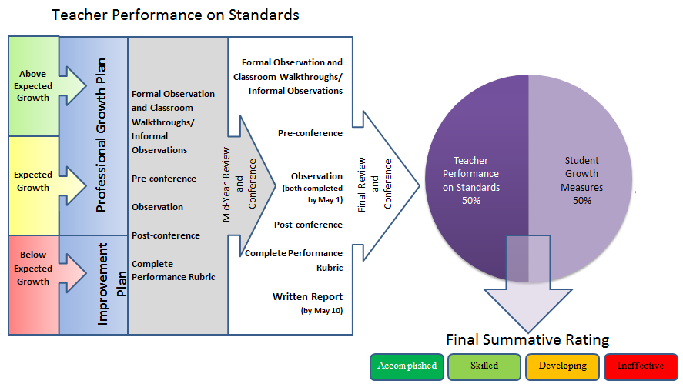

Ohio Teacher Evaluation System | Student Growth Measures

Student Growth Measures
Student growth measures shall account for fifty percent (50%) of the teacher evaluation. For the purpose of use in the OTES model, student growth is defined as the change in student achievement for an individual student between two or more points in time.
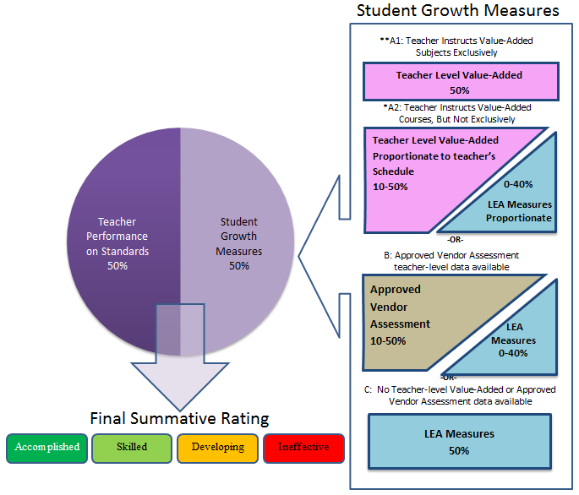

Ohio Teacher Evaluation System | Student Growth Measures

In Ohio’s LEAs the student growth component will be comprised of a combination of the following measures based on data availability and LEA decisions.
A | Teacher Value-Added | - MUST use if available  - 10-50% if applicable  - Phased-in implementation of reading and math, grades 4-8  - Extended reporting (other grades and subjects) being piloted  - EVAAS Value-Added metric, aggregated across subject areas  - 1-year report; or 2- or 3-year rolling average, based on availability
B | Vendor Assessments | - MUST use if LEA has assessment in place  - 10-50% if applicable and no Value-Added data available  - From ODE-Approved List  - Vendors demonstrate how assessment can measure growth
C | LEA-Determined Measures | - MAY use: LEA decision (Teacher Groups A & B)  - 0-40% if used in combination with Type One or Two measures  - MUST use (Teacher Group C)  - 50% if no Type One or Two data available  - Three types of LEA-Determined Measures  - Student Learning Objectives (SLOs) process for using measures that are specific to relevant subject matter. Measures for SLOs must be district-approved and may include:  - District-approved, locally developed assessments  - Pre/Post assessments  - Interim assessments  - Performance-based assessments  - Portfolios  - Shared attribution measures to encourage collaborative goals and may include:  - Building or District Value-Added is recommended if available  - Building teams (such as content area) may utilize a composite Value-Added score  - Performance Index gains  - Building or District-based SLOs  - Teacher Group A (with Value-Added) may also use Vendor assessments as a LEA-determined measure if using both

The combination of measures within the OTES model will vary depending on the grades and subjects taught. The guidelines and further information given will be updated as research and best practices emerge to inform revisions. Please see the Ohio Department of Education webpage for more information. The combination of measures will fall into three categories: a) Teachers with Value-Added data available; b) Teachers with approved Vendor Assessment data available; c) Teachers with no teacher-level Value-Added or Approved Vendor Assessment data available. Some combinations of measures, based on LEA decisions, may include a shared attribution measure such as building level data.

Ohio Teacher Evaluation System | Student Growth Measures

Why measure student growth?
According to the National Comprehensive Center for Teacher Quality (NCCTQ), the focus on evaluating educators by measuring growth rather than attainment is fairer to teachers and principals whose students enter classrooms well below grade level. These measures have the potential to inform instruction, build stakeholder commitment, provide a critical dimension to the assessment of teacher effectiveness, and, most important, improve student performance across a broader set of expectations.

Important terms and definitions
Student growth. For the purpose of use in evaluation systems, student growth is defined as “the change in student achievement for an individual student between two or more points in time” (excerpted from Measuring Student Growth for Teachers in Non–Tested Grades and Subjects: A Primer).

Tested grades and subjects. The US Department of Education (ED) defines “tested grades and subjects” as those covered by the state’s assessment under the ESEA and “non‐tested grades and subjects” as those without such data. Because the definition of student growth requires individual student achievement data from two or more points in time, this definition typically limits the tested grades and subjects to grades 4–10 in the subjects of English language arts and mathematics. In Ohio, this is limited to reading and math, grades 4-8.

Value-Added. In Ohio, Value-Added refers to the EVAAS Value-Added methodology. This is distinct from the more generic use of the term “value added” which can represent a variety of statistical modeling techniques. The Ohio, EVAAS Value-Added measure of student progress at the district and school level has been a component of the Ohio Accountability system for several years. Ohio’s Race to the Top plan provides for the expansion of Value-Added to the Teacher-level. Additionally, the EVAAS data reporting system has added several helpful features to help educators use this important data. Battelle for Kids (BFK) is providing professional development and other related services across the state.

Vendor Assessment. Ohio Revised Code requires the Department to “develop a list of student assessments that measure mastery of the course content for the appropriate grade level, which may include nationally normed standardized assessments, industry certification examinations, or end-of-course examinations” for grade levels and subjects for which the Value-Added measure does not apply (the “non-tested” grades). ODE released a Request for Qualifications (RFQ) whereby interested vendors could demonstrate qualifications. The List of approved assessments will be maintained and updated by ODE.

Student Learning Objectives (SLOs). SLOs are goals identified by a teacher or group of teachers that identify expected learning outcomes or growth targets for a group of students over a period of time. SLOs are determined by teachers after analyzing data on student academic performance and identifying areas in need of targeted effort for all students and subgroups of students. As a way to measure student growth, SLOs demonstrate a teacher’s impact on student learning within a given interval of instruction. Further, they enable teachers to use their own knowledge of appropriate student progress to make meaningful decisions about how their students’ learning is measured. As a collaborative process, SLOs also support teacher teams in their use of best practices.

Multiple measures. The teacher evaluation framework is based on multiple measures of performance and student growth. It is important that the holistic evaluation rating consider multiple factors across time. Accordingly, there are multiple measures within teacher performance and student growth, within and across years. The student growth measures may include data from multiple assessments and subjects.

Teacher Value-Added, by methodological definition, includes multiple measures on multiple levels. First, the EVAAS methodology incorporates students’ test histories (across all state-tested subjects) in determining growth metrics. Second, Value-Added creates effectiveness ratings for each tested grade and subject, as well as an aggregate composite rating. So for example and analogous to Value-Added on the Local Report Card, a 5th grade teacher may have a Value-Added rating for 5th grade math, a separate rating for 5th grade reading, and an overall composite rating. Third, the Value-Added metric will eventually roll into a three-year average so that multiple years of multiple measures are represented.
Ohio Teacher Evaluation System | Combining Teacher Performance and Student Growth Measures

Teacher performance and student growth measures are combined in a summative teacher evaluation rating:
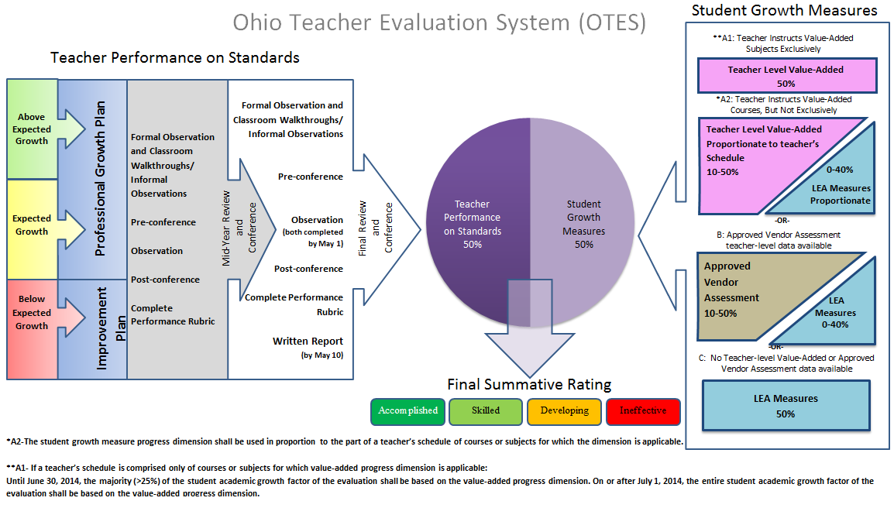

Ohio Teacher Evaluation System | Combining Teacher Performance and Student Growth Measures

Each category’s sub-scores are combined on the *lookup table to determine rating. The vertical axis of the lookup table represents student growth measures, and the horizontal axis on the table represents teacher performance. By using the lookup table, a final summative rating will be determined. See Appendix C (under development, to be added at a later date) for further information.

 |  | Teacher Performance
 |  | 4 |  | 3 |  | 2 |  | 1
Student Growth | Above |  | Accomplished |  | Accomplished |  | Skilled |  | Developing
Student Growth | Expected |  | Skilled |  | Skilled |  | Developing |  | Developing
Student Growth | Below |  | Developing |  | Developing |  | Ineffective |  | Ineffective

*Pending state board adoption.

Ohio Teacher Evaluation System Model | Implementing the OTES Model: Professional Growth Plan and Performance on the Standards

Requirements for Professional Growth Plan or Improvement Plan
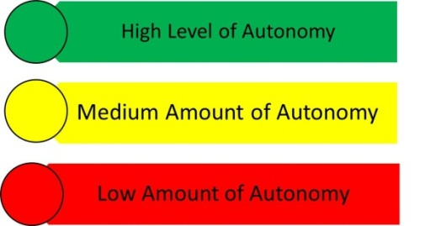
Processes: A Professional Growth Plan or an Improvement Plan is based on Student Growth Measures as designated on the Summative Evaluation Matrix and/ or performance on the standards as noted in the teacher performance rubric (see Appendix A).
Above  Expected Growth | Expected Growth | Below  Expected Growth | Description of Requirements  for  Professional Growth or Improvement Plan
 |  |  | Growth Plan
 |  |  | Improvement Plan
 |  |  | Self-Directed by Teacher
 |  |  | Collaborative –Teacher and Evaluator
 |  |  | Directed by the Evaluator
 |  |  | Professional Conversations
 |  |  | Mid-Year Progress Check
 |  |  | End-of-Year Evaluation

Professional Conversations and Progress Checks
As the teacher and evaluator work together during the formative assessment process, scheduled conferences should take place several times during the year to provide opportunities for professional conversation or direction about performance, goals, progress, as well as supports needed. During the year, the evaluator and teacher should discuss opportunities for professional development that evolve as a result of the evaluation process. The professional growth plan will be evaluated through indicators as described in the teacher performance rubric.

Professional Growth Plan
Professional Growth Plans help teachers focus on areas of professional development that will enable them to improve their practice. Teachers are accountable for the implementation and completion of the plan and may use the plan as a starting point for the school year. (The Professional Growth Plan is intended to be one academic year in duration and may support the goals of the Individual Professional Development Plan- IPDP. The Professional Growth Plan is not intended to replace the IPDP.) The professional growth plan and process includes feedback from the evaluator as well as the teacher’s self-assessment, and the support needed to further the teacher’s continuous growth and development. Professional development should be individualized to the needs of the teacher and students (based on available data), and specifically relate to the teacher’s areas for growth as identified in the teacher’s evaluation. The evaluator should recommend professional development opportunities, and support the teacher by providing resources (e.g., time, financial). The growth plan should be reflective of the data available and include:
- Identification of area(s) for future professional growth;
- Specific resources and opportunities to assist the teacher in enhancing skills, knowledge and practice;
- Outcomes that will enable the teacher to increase student learning and achievement.
Ohio Teacher Evaluation System Model | Implementing the OTES Model: Improvement Plan and Performance on the Standards

Improvement Plan
Improvement Plans are developed for a teacher by the evaluator in response to ineffective ratings in performance and/or student growth. The Improvement Plan is intended to identify specific areas for improvement of performance and for identifying guidance and support needed to help the teacher improve. [A plan of improvement may be initiated at any time during the evaluation cycle by the evaluator based on deficiencies in performance as documented by evidence collected by the evaluator.] District collective bargaining unit agreements should be consulted to determine additional conditions under which improvement plans are instituted. When an improvement plan is initiated by an administrator, it is the responsibility of the administrator to:
- Identify, in writing, the specific area(s) for improvement to be addressed in relationship to the Ohio Standards for the Teaching Profession;
- Specify, in writing, the desired level of performance that is expected to improve and a reasonable period of time to correct the deficiencies;
- Develop and implement a written plan for improvement that will be initiated immediately and includes resources and assistance available;
- Determine additional education or professional development needed to improve in the identified area(s);
- Gather evidence of progress or lack of progress.

A reassessment of the educator’s performance shall be completed in accordance with the written plan (multiple opportunities for observation of performance). Upon reassessment of the educator’s performance, if improvement has been documented at an acceptable level of performance**, the regular evaluation cycle will resume. If the teacher’s performance continues to remain at an ineffective level, the supervising administrator may reinstate the improvement plan with additional recommendations for improvement or take the necessary steps to recommend dismissal.

*Local negotiated agreement requirements should be consulted when developing Professional Growth Plans and Improvement Plans.

Ohio Teacher Evaluation System Model | Implementing the OTES Model: Observation Process and Performance on the Standards

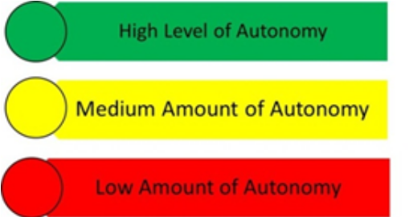
Assessment of Teacher Performance

All teachers, at all stages of their careers, will be assessed on their expertise and performance—in the classroom and school setting. Teachers with above expected levels of student growth may choose their credentialed evaluator for the evaluation cycle. Teachers with expected levels of student growth will have input on their credentialed evaluator for the evaluation cycle. Teachers with below expected levels of student growth will be assigned the credentialed evaluator for the evaluation cycle. A credentialed evaluator is one who:
- possesses the proper certification/ licensure to be an evaluator or the LEA has deemed that peers may be evaluators
- has been approved as an evaluator by the local board of education
- has completed a state-sponsored OTES training
- has passed an online assessment using the OTES rubric.

The Formal Observation Process
Observations of teaching provide important evidence when assessing a teacher’s performance and effectiveness. As an evaluator observes a teacher engaging students in learning, valuable evidence may be collected on multiple levels. As part of the formal observation process, on-going communication and collaboration between evaluator and teacher help foster a productive professional relationship that is supportive and leads to a teacher’s professional growth and development. Based upon researched best practices, the formal observation process consists of a pre-conference, classroom observation (and walkthroughs), and a post-conference.

Pre-Conference: Planning and observation of classroom teaching and learning
At the Pre-Conference, the evaluator and teacher discuss what the evaluator will observe during the classroom visitation. Important information is shared about the characteristics of the learners and learning environment. Specific information is also shared about the objectives of the lesson, and the assessment of student learning. The conference will also give the teacher an opportunity to identify areas in which she/he would like focused feedback from the evaluator during the classroom observation. The communication takes place during a formal meeting and a record of the date(s) should be kept. The purpose of the pre-observation conference is to provide the evaluator with an opportunity to discuss the following:
- Lesson or unit objective(s)
- Prior learning experiences of the students
- Characteristics of the learners/learning environment
- Instructional strategies that will be used to meet the lesson objectives
- Student activities and materials
- Differentiation based on needs of students
- Assessment (data) collected to demonstrate student learning

NOTE: The teacher and evaluator should set a time for the formal observation to take place, and re-negotiate this scheduled date and time as necessary if the observation is not conducted as planned.
Ohio Teacher Evaluation System Model | Implementing the OTES Model: Observation Process and Performance on the Standards

Formal Observation: Gathering evidence of teacher performance
Teachers will participate in a minimum of two formal observations. A formal observation consists of a visitation of a class period or the viewing of a class lesson. The observation should be conducted for an entire class period, lesson, or a minimum of 30 minutes. During the classroom observation, the evaluator documents specific information related to teaching and learning. Each formal observation will be analyzed by the evaluator using the Teacher Performance Evaluation Rubric. A narrative will then be completed by the evaluator to document each formal observation. The results of each formal observation are reviewed with the teacher during the post-observation conference. Formal observations will not include videotaping or sound recordings except with the written permission of the teacher.

Classroom walkthroughs are informal observations less than 30 minutes. These may occur frequently and may be unannounced.
Suggestions for Conducting the Post-Conference

- Introduction/Greeting/Establish Length
  - Review Conference Process
  - General Impression Question
“How do you think the lesson went?”
- Reinforcing the Teacher
  - Identify an area of Reinforcement (ONLY one area)
  - Ask Self-Analysis Question
  - Provide evidence from notes
- Refining the Teacher’s Skill:
  - Identify an area of Refinement (ONLY one area)
  - Ask Self-Analysis Question
  - Provide evidence from notes
  - Give a recommendation for future practice
4. Present evidence and rating connected to the rubric

Post-Conference: Reflection, reinforcement, and refinement
The purpose of the post-observation conference is to provide reflection and feedback on the observed lesson and to identify strategies and resources for the teacher to incorporate in lessons to increase effectiveness. Following the lesson, the teacher reflects on the lesson and how well the student learning outcomes were met. Professional conversations between the evaluator and the teacher during the Post-Conference will provide the teacher with feedback on the observed lesson, and may identify additional strategies and resources. The evaluator will make recommendations and commendations which may become part of the teacher’s professional development plan.

In general, the discussion between the evaluator and teacher needs to focus on how successful the lesson was (reinforcement), areas needing further support (refinement). Teachers may bring additional evidence that supports the lesson observed to share with the evaluator at the conference. The evaluator may consider these as evidence of student learning or evidence to support the teacher’s performance.

Combining Measures to Obtain a Holistic Rating
A strong teacher evaluation system calls for ongoing collaboration and honest conversation between teachers and their evaluators. The foundation of such a system is the transparent, two-way gathering and sharing of evidence that informs the teacher performance ratings at the end of the year. Some teacher behaviors are observable in the classroom while other evidence may include formal conferences, informal conversations, evidence of practice, and colleague, parent and student input. The model Ohio Teacher Evaluation System describes opportunities for teachers and evaluators to discuss evidence, build a common understanding of the teacher’s current practice, and identify areas for future growth. Regular check-ins also help evaluators manage the administrative burden of gathering and organizing evidence by sharing the responsibility with the teacher and encouraging evaluators to document teacher practices as they occur.

For suggested step-by-step guidance for evaluators to review and analyze multiple data points that inform teacher performance ratings, please see Appendix B: Using Evidence to Inform Holistic Performance Ratings.
Ohio Teacher Evaluation System Model | Implementing the OTES Model: Student Growth Measures

Assessment of Student Growth
Student growth measures shall account for fifty percent (50%) of the teacher evaluation. For the purpose of use in the OTES model, student growth is defined as the change in student achievement for an individual student between two or more points in time. In Ohio’s LEAs the student growth component will be comprised of a combination of two or more measures of Value-Added scores, Vendor-created assessments, and LEA determined student growth measures.

Three categories of teachers based on availability of Teacher Value-Added and LEA decisions
It is important to note that the combination of measures within this general framework will vary depending on the grades and subjects taught. There is not enough research yet to say which combination of measures will provide the most accurate and useful information about teacher effectiveness. Therefore, these guidelines shall be updated as research and best practices emerge to inform revisions. Subsequently, the specific student growth components will be divided into three categories for teachers based on the availability of Teacher Value-Added and LEA decisions:
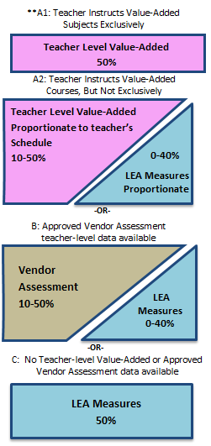

As the teacher evaluation system is implemented and matures, LEAs may consider a phased-in, stepped approach in designing percentage breakdowns within categories. Some student growth data will be based on the previous year’s results (due to testing schedules and evaluation requirements for evaluation schedule). The Value-Added metric will utilize a three-year average, which will itself mature on a rolling basis as LEAs implement teacher Value-Added on a phased-in schedule beginning in 2010-11.

APPENDIX A
Ohio Teacher Evaluation System Model | Teacher Performance Rubric
Teacher Performance Evaluation Rubric

The Teacher Performance Evaluation Rubric is intended to be scored holistically. This means that evaluators will assess which level provides the best overall description of the teacher. The scoring process is expected to occur upon completion of each thirty (30) minute observation and post-conference. The evaluator is to consider evidence gathered during the pre-observation conference, the observation, the post-observation conference, and classroom walkthroughs (if applicable). When completing the performance rubric, please note that evaluators are not expected to gather evidence on all indicators for each observation cycle. Likewise, teachers should not be required to submit additional pieces of evidence to address all indicators. The professionalism section of the rubric may use evidence collected during the pre-observation and post-observation conferences as well as information from the Professional Growth and/or Improvement Plan (if applicable).

INSTRUCTIONAL PLANNING
 |  | Ineffective | Developing | Skilled | Accomplished
INSTRUCTIONAL PLANNING | FOCUS FOR LEARNING  (Standard 4: Instruction)  Sources of Evidence:  Pre-Conference | The teacher does not demonstrate a clear focus for student learning. Learning objectives are too general to guide lesson planning and are inappropriate for the students, and/or do not reference the Ohio standards. | The teacher communicates a focus for student learning, develops learning objectives that are appropriate for students and reference the Ohio standards but do not include measureable goals. | The teacher demonstrates a focus for student learning, with appropriate  learning objectives that include measurable goal(s) for student learning aligned with the Ohio standards. The teacher demonstrates the importance of the goal and its appropriateness for students. | The teacher establishes challenging and measurable goal(s) for student learning that aligns with the Ohio standards and reflect a range of student learner needs.  The teacher demonstrates how the goal(s) fit into the broader unit, course, and school goals for content learning and skills.
INSTRUCTIONAL PLANNING | ASSESSMENT DATA  (Standard 3: Assessment)  Sources of Evidence:  Pre-Conference | The teacher does not plan for the assessment of student learning or does not analyze student learning data to inform lesson plans. | The teacher explains the characteristics, uses, and limitations of various diagnostic, formative, and summative assessments but does not consistently incorporate this knowledge into lesson planning. | The teacher demonstrates an understanding that assessment is a means of evaluating and supporting student learning through effectively incorporating diagnostic, formative, and/or summative assessments into lesson planning. | The teacher purposefully plans assessments and differentiates assessment choices to match the full range of student needs, abilities, and learning styles, incorporating a range of appropriate diagnostic, formative, and summative assessments into lesson plans.
INSTRUCTIONAL PLANNING |  | The teacher does not use or only uses one measure of student performance. | The teacher uses more than one measure of student performance but does not appropriately vary assessment approaches, or the teacher may have difficulty analyzing data to effectively inform instructional planning and delivery. | The teacher employs a variety of formal and informal assessment techniques to collect evidence of students’ knowledge and skills and analyzes data to effectively inform instructional planning and delivery. | Student learning needs are accurately identified through an analysis of student data; the teacher uses assessment data to identify student strengths and areas for student growth.

INSTRUCTIONAL PLANNING
 |  | Ineffective | Developing | Skilled | Accomplished
INSTRUCTIONAL PLANNING | PRIOR CONTENT KNOWLEDGE / SEQUENCE / CONNECTIONS  (Standard 1: Students; Standard 2: Content; Standard 4: Instruction)  Sources of Evidence:  Pre-Conference | The teacher’s lesson does not build on or connect to students’ prior knowledge, or the teacher may give an explanation that is illogical or inaccurate as to how the content connects to previous and future learning. | The teacher makes an attempt to connect the lesson to students’ prior knowledge, to previous lessons or future learning but is not completely successful. | The teacher makes clear and coherent connections with students’ prior knowledge and future learning—both explicitly to students and within the lesson. | The teacher uses the input and contributions of families, colleagues, and other professionals in understanding each learner’s prior knowledge and supporting their development. The teacher makes meaningful and relevant connections between lesson content and other disciplines and real-world experiences and careers as well as prepares opportunities for students to apply learning from different content areas to solve problems.
INSTRUCTIONAL PLANNING |  |  |  | The teacher plans and sequences instruction to include the important content, concepts, and processes in school and district curriculum priorities and in state standards. | The teacher plans and sequences instruction that reflects an understanding of the prerequisite relationships among the important content, concepts, and processes in school and district curriculum priorities and in state standards as well as multiple pathways for learning depending on student needs. The teacher accurately explains how the lesson fits within the structure of the discipline.
INSTRUCTIONAL PLANNING | KNOWLEDGE OF STUDENTS  (Standard 1: Students)  Sources of Evidence:  Analysis of Student Data  Pre-Conference | The teacher demonstrates a lack of familiarity with students’ backgrounds and has made no attempts to find this information. | The teacher demonstrates some familiarity with students’ background knowledge and experiences and describes one procedure used to obtain this information. | The teacher demonstrates familiarity with students’ background knowledge and experiences and describes multiple procedures used to obtain this information. | The teacher demonstrates an understanding of the purpose and value of learning about students’ background experiences, demonstrates familiarity with each student’s background knowledge and experiences, and describes multiple procedures used to obtain this information.
INSTRUCTIONAL PLANNING |  | The teacher’s plan for instruction does not demonstrate an understanding of students’ development, preferred learning styles, and/or student backgrounds/prior experiences. | The teacher’s instructional plan draws upon a partial analysis of students’ development, readiness for learning, preferred learning styles, or backgrounds and prior experiences and/or the plan is inappropriately tailored to the specific population of students in the classroom. | The teacher’s instructional plan draws upon an accurate analysis of the students’ development, readiness for learning, preferred learning styles, and backgrounds and prior experiences. | The teacher’s analysis of student data (student development, student learning and preferred learning styles, and student backgrounds/prior experiences) accurately connects the data to specific instructional strategies and plans.  The teacher plans for and can articulate specific strategies, content, and delivery that will meet the needs of individual students and groups of students.

Instruction and Assessment
 |  | Ineffective | Developing | Skilled | Accomplished
INSTRUCTION AND ASSESSMENT | LESSON DELIVERY  (Standard 2: Content; Standard 4: Instruction; Standard 6: Collaboration and Communication)  Sources of Evidence:  Formal Observation  Classroom Walkthroughs/ Informal Observations | A teacher’s explanations are unclear, incoherent, or inaccurate, and are generally ineffective in building student understanding. The teacher uses language that fails to engage students, is inappropriate to the content, and/or discourages independent or creative thinking. | Teacher explanations are accurate and generally clear but the teacher may not fully clarify information based on students’ questions about content or instructions for learning activities or the teacher may use some language that is developmentally inappropriate, leading to confusion or limiting discussion. | Teacher explanations are clear and accurate. The teacher uses developmentally appropriate strategies and language designed to actively encourage independent, creative, and critical thinking. | Teacher explanations are clear, coherent, and precise. The teacher uses well-timed, individualized, developmentally appropriate strategies and language designed to actively encourage independent, creative, and critical thinking, including the appropriate use of questions and discussion techniques.
INSTRUCTION AND ASSESSMENT |  | The teacher fails to address student confusion or frustration and does not use effective questioning techniques during the lesson. The lesson is almost entirely teacher-directed. | The teacher re-explains topics when students show confusion, but is not always able to provide an effective alternative explanation. The teacher attempts to employ purposeful questioning techniques, but may confuse students with the phrasing or timing of questions. The lesson is primarily teacher-directed. | The teacher effectively addresses confusion by re-explaining topics when asked and ensuring understanding. The teacher employs effective, purposeful questioning techniques during instruction. The lesson is a balance of teacher-directed instruction and student-led learning. | The teacher accurately anticipates confusion by presenting information in multiple formats and clarifying content before students ask questions. The teacher develops high-level understanding through effective uses of varied levels of questions. The lesson is student-led, with the teacher in the role of facilitator.
INSTRUCTION AND ASSESSMENT | DIFFERENTIATION  (Standard 1: Students; Standard 4: Instruction)  Sources of Evidence:  Pre-Conference  Formal Observation  Classroom Walkthroughs/ Informal Observations | The teacher does not attempt to make the lesson accessible and challenging for most students, or attempts are developmentally inappropriate. | The teacher relies on a single strategy or alternate set of materials to make the lesson accessible to most students though some students may not be able to access certain parts of the lesson and/or some may not be challenged. | The teacher supports the learning needs of students through a variety of strategies, materials, and/or pacing that make learning accessible and challenging for the group.. | The teacher matches strategies, materials, and/or pacing to students’ individual needs, to make learning accessible and challenging for all students in the classroom . The teacher effectively uses independent, collaborative and whole-class instruction to support individual learning goals and provides varied options for how students will demonstrate mastery.
INSTRUCTION AND ASSESSMENT | RESOURCES  (Standard 2: Content; Standard 4: Instruction)  Sources of Evidence:  Pre-Conference  Formal Observation  Classroom Walkthroughs/ Informal Observations | Instructional materials and resources used for instruction are not relevant to the lesson or are inappropriate for students. | The teacher uses appropriate instructional materials to support learning goals, but may not meet individual students’ learning styles/needs or actively engage them in learning. | Instructional materials and resources are aligned to the instructional purposes and are appropriate for students’ learning styles and needs, actively engaging students. | Instructional materials and resources are aligned to instructional purposes, are varied and appropriate to ability levels of students, and actively engage them in ownership of their learning.

Instruction and Assessment
 |  | Ineffective | Developing | Skilled | Accomplished
INSTRUCTION AND ASSESSMENT | CLASSROOM ENVIRONMENT  (Standard 1: Students; Standard 5: Learning Environment; Standard 6: Collaboration and Communication)  Sources of Evidence:  Pre-Conference  Formal Observation  Classroom Walkthroughs/ Informal Observations | There is little or no evidence of a positive rapport between the teacher and students. For example, the teacher may respond disrespectfully to students or ignore their questions or comments. | The teacher is fair in the treatment of students and establishes a basic rapport with them. For example, the teacher addresses students questions or comments but does not inquire about their overall well-being. | The teacher has positive rapport with students and demonstrates respect for and interest in all students. For example, the teacher makes eye contact and connects with individual students. | The teacher has positive rapport with students and demonstrates respect for and interest in individual students’ experiences, thoughts and opinions. For example, the teacher responds quietly, individually, and sensitively to student confusion or distress.
INSTRUCTION AND ASSESSMENT |  | There are no evident routines or procedures; students seem unclear about what they should be doing or are idle. | Routines and procedures are in place, but the teacher may inappropriately prompt or direct students when they are unclear or idle. | Routines and procedures run smoothly throughout the lesson, and students assume age-appropriate levels of responsibility for the efficient operation of the classroom. | Routines are well-established and orderly and students initiate responsibility for the efficient operation of the classroom.
INSTRUCTION AND ASSESSMENT |  | Transitions are inefficient with considerable instructional time lost. Lessons progress too slowly or quickly so students are frequently disengaged. | The teacher transitions between learning activities, but occasionally loses some instructional time in the process. | Transitions are efficient and occur smoothly. There is evidence of varied learning situations (whole class, cooperative learning, small group and independent work). | Transitions are seamless as the teacher effectively maximizes instructional time and combines independent, collaborative, and whole-class learning situations.
INSTRUCTION AND ASSESSMENT |  | The teacher creates a learning environment that allows for little or no communication or engagement with families. | The teacher welcomes communication from families and replies in a timely manner. | The teacher engages in two-way communication and offers a variety of volunteer opportunities and activities for families to support student learning. | The teacher engages in two-way, ongoing communication with families that results in active volunteer, community, and family partnerships which contribute to student learning and development.
INSTRUCTION AND ASSESSMENT |  | Expectations for behavior are not established or are inappropriate and/or no monitoring of behaviors occurs. The teacher responds to misbehavior inappropriately. | Appropriate expectations for behavior are established, but some expectations are unclear or do not address the needs of individual students. The teacher inconsistently monitors behavior. | A classroom management system has been implemented that is appropriate and responsive to classroom and individual needs of students. Clear expectations for student behavior are evident . Monitoring of student behavior is consistent, appropriate, and effective. | A classroom management system has been designed, implemented, and adjusted with student input and is appropriate for the classroom and individual student needs. Students are actively encouraged to take responsibility for their behavior. The teacher uses research-based strategies to lessen disruptive behaviors and reinforce positive behaviors.

Instruction and Assessment
 |  | Ineffective | Developing | Skilled | Accomplished
INSTRUCTION AND ASSESSMENT | ASSESSMENT OF STUDENT LEARNING  (Standard 3: Assessment)  Sources of Evidence:  Pre-Conference  Formal Observation  Classroom Walkthroughs/ Informal Observations  Post-Conference | The teacher does not routinely use assessments to measure student mastery. | The teacher uses assessments to measure student mastery, but may not differentiate instruction based on this information. | The teacher uses assessment data to identify students’ strengths and needs, and modifies and differentiates instruction accordingly, although the teacher may not be able to anticipate learning obstacles. | The teacher uses assessment data to identify students’ strengths and needs, and modifies and differentiates instruction accordingly, as well as examines classroom assessment results to reveal trends and patterns in individual and group progress and to anticipate learning obstacles.
INSTRUCTION AND ASSESSMENT |  | The teacher rarely or never checks the students’ understanding of content. The teacher fails to make adjustments in response to student confusion. | The teacher checks for student understanding and makes attempts to adjust instruction accordingly, but these adjustments may cause some additional confusion | The teacher checks for understanding at key moments and makes adjustments to instruction (whole-class or individual students).The teacher responds to student misunderstandings by providing additional clarification. | The teacher continually checks for understanding and makes adjustments accordingly (whole-class or individual students). When an explanation is not effectively leading students to understand the content, the teacher adjusts quickly and seamlessly within the lesson and uses an alternative way to explain the concept.
INSTRUCTION AND ASSESSMENT |  | The teacher persists in using a particular strategy for responding to misunderstandings, even when data suggest the approach is not succeeding. | The teacher gathers and uses student data from a few sources to choose appropriate instructional strategies for groups of students. | The teacher gathers and uses student data from a variety of sources to choose and implement appropriate instructional strategies for groups of students. | By using student data from a variety of sources, the teacher appropriately adapts instructional methods and materials and paces learning activities to meet the needs of individual students as well as the whole class.
INSTRUCTION AND ASSESSMENT |  | The teacher does not provide students with feedback about their learning. | Students receive occasional or limited feedback about their performance from the teacher. | The teacher provides substantive, specific, and timely feedback of student progress to students, families, and other school personnel while maintaining confidentiality. | The teacher provides substantive, specific, and timely feedback to students, families, and other school personnel while maintaining confidentiality. The teacher provides the opportunity for students to engage in self-assessment and show awareness of their own strengths and weaknesses. The teacher uses student assessment results to reflect on his or her own teaching and to monitor teaching strategies and behaviors in relation to student success.

Professionalism
 |  | Ineffective | Developing | Skilled | Accomplished
PROFESSIONALISM | PROFESSIONAL RESPONSIBILITIES  (Standard 6: Collaboration and Communication; Standard 7: Professional Responsibility and Growth)  Sources of Evidence:  Professional Development Plan or Improvement Plan; Pre-conference;  Post-conference;  daily interaction with others | The teacher fails to communicate clearly with students and families or collaborate effectively with professional colleagues. | The teacher uses a variety of strategies to communicate with students and families and collaborate with colleagues, but these approaches may not always be appropriate for a particular situation or achieve the intended outcome. | The teacher uses effective communication strategies with students and families and works effectively with colleagues to examine problems of practice, analyze student work, and identify targeted strategies. | The teacher communicates effectively with students, families, and colleagues. The teacher collaborates with colleagues to improve personal and team practices by facilitating professional dialogue, peer observation and feedback, peer coaching and other collegial learning activities.
PROFESSIONALISM |  | The teacher fails to understand and follow regulations, policies, and agreements. | The teacher understands and follows district policies and state and federal regulations at a minimal level. | The teacher meets ethical and professional responsibilities with integrity and honesty. The teacher models and upholds district policies and state and federal regulations. | The teacher meets ethical and professional responsibilities and helps colleagues access and interpret laws and policies and understand their implications in the classroom.
PROFESSIONALISM |  | The teacher fails to demonstrate evidence of an ability to accurately self-assess performance and to appropriately identify areas for professional development. | The teacher identifies strengths and areas for growth to develop and implement targeted goals for professional growth. | The teacher sets data-based short- and long-term professional goals and takes action to meet these goals. | The teacher sets and regularly modifies short-and long-term professional goals based on self-assessment and analysis of student learning evidence.

Ohio Teacher Evaluation System Model | Implementing the OTES Model: Holistic Rating  Appendix B

Using Evidence to Inform Holistic Performance Ratings

Defining the Performance Ratings
In accordance with Ohio Revised Code 3319.112 the rubric describes four levels of teacher performance for each standard area. Each performance rating can also be described in more general terms, as a holistic rating of teacher performance:
Accomplished:

A rating of Accomplished indicates that the teacher is a leader and model in the classroom, school, and district, exceeding expectations for performance. The teacher consistently strives to improve his or her instructional and professional practice and contributes to the school or district through the development and mentoring of colleagues.

Skilled:

A rating of Skilled indicates that the teacher consistently meets expectations for performance and fully demonstrates most or all competencies. This rating is the rigorous, expected performance level for most experienced teachers.
Developing:

A rating of Developing indicates that the teacher demonstrates minimum competency in many of the teaching standards, but may struggle with others. The teacher is making progress but requires ongoing professional support for necessary growth to occur.
Ineffective:

A rating of Ineffective indicates that the teacher consistently fails to demonstrate minimum competency in one or more teaching standards. There is little or no improvement over time. The teacher requires immediate assistance and needs to be placed on an improvement plan.

Teacher Evaluation relies on two key evaluation components: a rating of Teacher Performance and a rating of student academic growth, each weighted at fifty percent of each evaluation. The following guidance speaks to the Teacher Performance rating component, utilizing the state model Teacher Performance Evaluation Rubric.
The following is suggested step-by-step guidance for evaluators to review and analyze multiple data points that inform teacher performance ratings.

Step 1: Gather evidence
1a. Align evidence to each standard area. Group the evidence you have collected from time in the classroom, conferences and everyday interactions with the teacher into the ten standard areas of performance described by the Teacher Performance Evaluation Rubric.

1b. Be consistent in gathering, recording, and sharing detailed, factual evidence. Capture enough detail to accurately but succinctly describe the event, interaction, or behavior factually (without implied judgment or opinion in the recording). Share the form with teachers throughout the year so that the information can be used as a basis for changes in practice.

1c. Sort the evidence by standard area to determine where more information is needed. As the year progresses, holes in evidence coverage across standard areas may emerge. If the evidence collected is organized by standard area after each interaction, it will be automatically sorted by standard area and missing evidence will be apparent. Keep these standard areas in mind during future interactions with the teacher, since all standard areas are important for effective teaching practice.

Step 2: Issue a holistic performance rating
2a. Read all of the evidence collected up to that point within a standard area, looking for patterns. For example, if a teacher talks about wanting to improve an instructional technique in a pre-conference, demonstrates that technique in the first formal classroom observation and an informal classroom “walk-through” and asks for feedback on the technique in the post-conference, that teacher is displaying a pattern of devoting attention to a particular area of practice. Note these patterns and take them into consideration when issuing a rating.

2b. Compare the evidence and patterns to the performance descriptors. After becoming familiar with the rubric, start by re-reading all of the Skilled performance descriptors in a standard area. Does the evidence exemplify this level of performance? Whether yes or no, look at the Accomplished or Developing performance level descriptors as well, to decide if either of them better aligns with the available evidence. If the Developing descriptor seems to be an appropriate match to the evidence, also read the Ineffective descriptor carefully to consider whether any evidence is at this level.

2c. Repeat the process above for each standard area, and then consider patterns of performance across standard areas. Once you determine a rating for each standard area, based on the available evidence from multiple interactions, look at the larger picture of performance across all standard areas. Although all standard areas are important for effective teacher practice, you may find it appropriate to more strongly weight patterns of behavior in one standard area over another. For example, if the teacher demonstrates a pattern of Developing behavior in the standard areas of Classroom Environment and Resources but exhibits solidly Skilled patterns of behavior in the standard area of Knowledge of Students and Lesson Delivery, you may use your knowledge of the situation to make sense of this information, finding that performance in the former two areas inhibits performance in other areas. As another example, you may find that some of the lost instructional time observed within a classroom is offset by the teacher’s intense attention to individual student needs demonstrated throughout the class time and elsewhere. In a different case, however, you might observe that a pattern of classroom management issues such as lost instructional time is significant enough to overshadow the teacher’s skilled performance in other categories. The key point is that no one standard area of performance should be considered in isolation, but should be analyzed in relation to all other areas of performance.

Step 3: Issue the end-of-year performance rating
3a. Consider all evidence from the year, paying attention to trends. In order to issue a teacher’s final performance rating for the year, return to the body of collected evidence rather than just the earlier standard area- or holistic ratings. Use the process outlined to reconsider the evidence in each standard area across the arc of the entire year, taking into account observations, all conferences, and daily interactions. During this step, it is particularly important to consider trends in the teacher’s performance over time. Was the teacher consistent in his or her practice, did he or she improve, or did the teacher decline in one or more areas? If a pattern of evidence in a particular standard area displays a trend of behavior or practice, the evaluator may consider placing more emphasis on the area improvement or decline.

3b. Consider minimum thresholds of competency. Flag any instance of an Ineffective rating as you prepare to issue the final performance rating. While the example of Ineffective behavior should be examined within the entire context of the evidence collected for the teacher, consider that there are minimum thresholds of competency for each of the ten standard areas described in the Teacher Performance Evaluation Rubric. It is possible that a serious deficiency in one area can and should carry more weight than positive ratings in other areas. Rely on your professional judgment, supported by the evidence you have gathered, to decide if this evidence of ineffective practice is grounds to issue a final ineffective rating, taking into account how detrimental the displayed deficiency is to the teacher’s classroom, colleagues and school as a whole.

3c. Issue the final performance rating, summarize the supporting evidence, and offer areas of reinforcement and refinement. Complete the performance rating process by documenting the final teacher performance rating. Support your rating with evidence from formal and informal observations, artifacts provided by the teacher, and other appropriate evidence collected throughout the evaluation cycle. Provide succinct, targeted feedback on what professional growth needs to occur so that teachers have a clear understanding of the path to continuous growth and improvement and have concrete examples of supports that will help them improve practice.

